Experiment #4

Long-term stand-off detection
These experiments should give an answer what extend environment influence (glass windows, rain, snow, fog, wind, humidity, atmospheric pressure, sunlight, dust, etc.) affects explosives decay sub-products detection using TDLS

Experiment tasks
Planning long-term monitoring of stand-off detection of decay sub-products we try to solve the following tasks:
- Stand-off detection through glass windows.
- Long-term monitoring in different weather conditions.
- Stand-off detection of decay products in closed apartments through the windows (additionally, on example of stand-off detection of presence of living species in closed apartment by excess of carbon dioxide in the air).

Place of experiment
Experiment was carried out on GPI territory. A map of experiment is shown on Fig. 1.
Fig. 1 A map of experiment.
The device for stand-off detection was installed on third (fourth in Russian numeration) floor in the lab room #414 of DLS Department of NSC GPI (NSC building is denoted on a map as red rectangular). Retroreflector was installed on the same floor in opposite building (Scientific center of Fiber Optics). Laser beam is shown on a map by blue line. The distance between device and retroreflector was about 30 m.

Block-scheme of experiment
According to the tasks declared above the measurements should be carried out at any weather and any time of the day. As would be seen further these tasks required solution of a series of principal problems.
Block-scheme of experiment is shown on Fig. 2.
This block-scheme does not reflect real experiment geometry, it shows only main points.
The device consisted of diode laser (DL), focusing lens, spherical mirror and photodetector (PD).
The laser used was pigtailed DL “NEL” (wavelength 1.58 μ). Exit connector of DL was fixed on optical desk of device. Focusing lens which coupled output DL radiation diagram was mounted on 3D translation stage.
Radiation, reflected back by retroreflector, was focused on a PD with a help of receiving mirror. Diameter of receiving mirror was twice as much of retroreflector diameter for better coupling.
Fig. 2. Block-scheme of experiment
This scheme of detection has been successfully applied in many previous experiments. A specific feature of this very experiment was a presence of closely positioned room windows, which turned out to be important. At first experiments the window in lab room where the device was installed was opened and the only window that crossed laser beam was window in opposite building where retroreflector was installed. A diameter of laser beam in this place was rather large (6 cm) and etalon fringes effects were negligible. A diameter of laser beam on closed window in lab room was much smaller and etalon fringes effects were significant and almost completely masked detected effects. That effect was observed on different diode lasers that were exploited in these experiments. In particular, specific oscillating dependence intrinsic for etalon fringes effects was observed when window was Sun illuminated causing changes in glass thickness due to heating. A solution of this problem was found when laser beam was focused on window glass as shown on Fig. 2. Although beam diameter became even smaller, the angle of divergence (convergence) became larger. That allowed suppression of etalon fringes effect and made possible this long-term experiment. This trick was applied in others experiments when it was necessary to detect gaseous species through winnow glass.

Choice of target molecule and spectral range
Among the molecules representing interest for stand-off detection CO₂ and not NH₃ was chosen for the following reasons. First, they were safety reasons. At the beginning it was necessary to have large concentration of detected gas in order to distinguish its signal from interfering effects. Although it is the same where detected gas would be released (in the lab room or into the room in opposite building where retroreflector was installed), to have large concentration of ammonia in either places was very inconvenient as long as people have to be present. (In experiments with ammonia with a help of multipass cell high concentration of ammonia was created in small volume of used box, meanwhile high concentration of ammonia for stand-off detection should be created in entire room). Second, carbon dioxide stand-off detection through closed windows may have its own practical interest – detection of presence of living beings into suspected apartments.

Fig. 3 shows absorption spectra in mid and near IR region. As could be seen, most preferable detection should be in the region of 2 μ.
Fig. 3 Spectrum of СO₂ in mid and near IR region and wavelengths of available diode lasers (red circles at the top of figure).
The diode laser for this region was purchased and was prepared for experiment. Unfortunately, we have lost it - it was burned down due to technical mistake. New one for the same region has been ordered and we wait for its arrival.
For the reported experiments another diode laser was chosen, its wavelength is shown on Fig. 3 by dashed arrow in the region of 1.58 μ. As could be seen, absorption in this region is approximately 100 lower. That made serious experimental difficulties for CO₂ detection and required improving in sensitivity 10 times better than it was achieved by leading teams in the world (save for our group). As could be seen from the below results, this task was solved.
Speaking about further perspectives, it should be noted that long-wavelength diode laser intended for these experiments (2 μ VCSEL) has essentially lower power (of an order of 0.5 mW compared to 10 – 20 available in near IR). Further more, effective optical amplifiers are also unavailable.
For spectral range that was used for these experiments (1.58 μ) optical amplifiers are available but as could be seen from Fig. 3, absorption is too small. Maybe a trade-off between these two possibilities lays in quite different region – 1.44 μ. As could seen from Fig. 3, absorption in this region is notably higher than in 1.58 μ, and optical amplifiers for this region are available. If it so or not, diode laser for this wavelength is ordered.

System functioning

Fig. 4 shows a sight of program interface that was used for preparation and accomplishment of experiment for CO₂ detection. Left upper graph shows current received analytic signal. Right upper graph shows processed signal in reference (yellow) and analytic (white) channels. As could be seen, waveform of analytic signal repeats one of reference signal. Using data presented on Fig. 3, the length of optical path (60 m) and typical CO₂ concentration in atmosphere (330 ppm), it is possible to estimate absorption caused by natural concentration of CO₂ in atmosphere. It should be 2*10⁻³. As could be seen, amplitude of absorption in analytic channel (right upper graph) is of the order of 10⁻³.

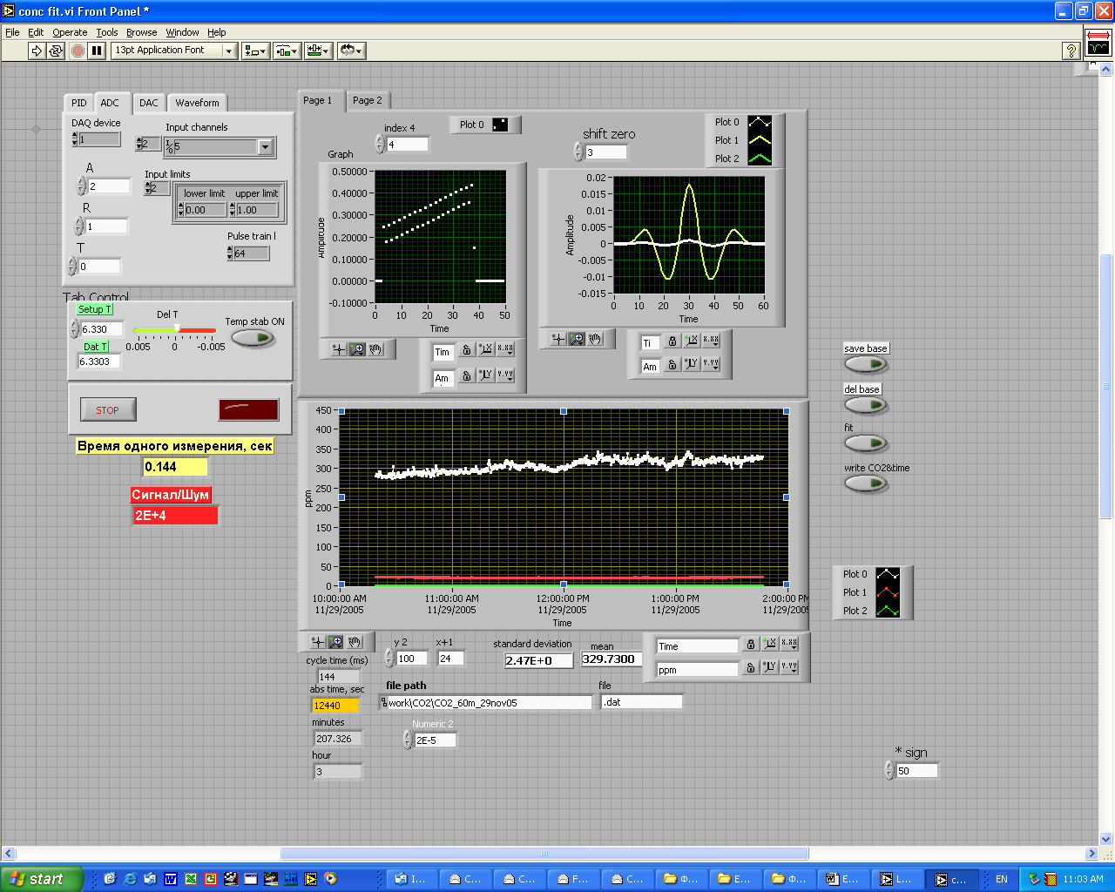
Fig. 4 Program interface used for CO₂ detection

Central graph on Fig. 4 shows time CO₂ concentration dependence measured 29th November 2005. It should be noted that in the first half of day there is tend for increasing (cars exhausts) and tend for decreasing in the second part of the day. These tends were observed in many other experiments (see further).

Experiment methodology
A geometry of this experiment implies that measured integral concentration of CO₂ consist of three parts: averaged concentration in lab room, averaged concentration in the room where retroreflector was installed, and averaged concentration in atmosphere between two buildings (Fig. 5).

Fig. 5 Block-scheme of experiment
Integral concentration of CO₂, measured by the device, is equal to

2*(C1*L1+C*L+C2*L2)/(L1+L+L2)

and is determined mostly by atmosphere between buildings.
The results of long-term experiment are shown on following figures. Experiment began 15th December 2005 at 15:55 and ended 20th December 2005 at 15:43, that is, it lasted 5 days 1 hour 52 minutes or 7312 minutes. Fig. 6 shows dependence of Sun illumination accidentally falling on the detector in analytic channel. Increasing of illumination corresponded to daytime – very short in Moscow at this time of year.
Fig. 6 Time dependence of Sun illumination falling upon the detector
Fig. 7 represents time dependence of signal amplitude. Changes of signal in a day after experiment beginning (end of first day) and the end of fives day correspond to readjustment of device, changes in the middle of graph are due to snowfall. As could be seen, snow leads to approximately 20 % fall of incoming signal.
Fig. 7 Time dependence of signal amplitude for the same experiment as on Fig. 7
Long-term CO₂ concentration dependence is shown Fig. 8. As on Fig. 7, changes at the end of first and fifth days corresponded to system adjustment. Slow variations of concentration follow daily changes of CO₂ in atmosphere – higher concentration during daytime mostly due to traffic and lower concentrations at nighttime. Two small pikes in the middle of graph presumably are due to snowfall.

Fig. 8 Long-term dependence of CO₂ concentration

Thus, device demonstrated rather good stability for working in winter conditions when being located in warm room and sensing object through closed windows. To obtain the results for rain influence we should wait for springtime or transport the device to warmer climate.
Another experiment with stand-off detection concerned detection of human beings presence in apartment by excess of CO₂. As the device measures integral concentration in three parts (see Fig. 5), to decrease an uncertainty apartment #1 was excluded – retroreflector was mounted near window, so optical path inside this room was very small. Contrary, the device in lab room #2 was located as far from window as possible to make optical path in this room longer.
One of first results is shown on Fig. 9.
Fig. 9 CO₂ time dependence - monitoring of presence people in lab room 17.11.2005.
The distance between two buildings was about L = 30 m, and distance from the device to window was L2 = 3 m. At the beginning of experiment the device was left unattended and none was present in the room. At 15:50 five persons came into lab room and at 16:10 they left it, the door into lab was left opened. Increase in CO₂ concentration in this period is obvious.
Room space could be estimated as 60 m³. Knowing that, averaged introduction of each person into CO₂ raise may be calculated: 0.7 ppm/(s person). It should be noted that noise level in this experiment corresponded to minimum detectible absorbance of 10⁻⁵. Using DL with operating wavelength of 2 μ sensitivity may be improved 100 times although distance would be less due to lower laser power.

