NEW TYPE OF TECHNOLOGICAL MATERIALS BASED OH HIGH-Tc SUPERCONDUCTORS:ULTRA FINE POWDERS AND BULK TEXTURED COMPOSITES FROM THEM

INTAS project 96-251

Scientific report (1.09.97-1.10.98)

Team of ISSP (Chernogolovka), prof. G.A.Emelchenko
Team of GPI (Moscow), Dr. Yu.V.Bugoslavsky

Contents

- Technique for production of nano-scale powders of high-Tc superconductors.
- Characterization of the nano-scale high-Tc powders
-Particle shape and size distribution
-X-ray data and electron diffraction
-Differential thermal analysis
-Critical temperature from the magnetic susceptibility measurements
-Oxygen index in YBCO
- Investigation of ceramic samples (composites) prepared from the nano-scale powders.
-Sample preparation technique
-Mechanical properties
-Magnetic measurements

1 Technique for production of nano-scale powders of high-Tc superconductors.

The powder was produced by the spark erosion method (we name the our modification – method of impulse plasma channel). The electrodes to which electric pulses were applied were made of YBa₂Cu₃O₇ ceramics and immersed into liquid oxygen (Fig1). When pulses power, duration and shape were chosen adequately, the substance evaporating from electrodes was condensed into almost spherical particles of the same chemical composition as that of the electrodes .

2. Characterization of the nano-scale high-T_{c} powders

- Particle shape and size distribution

YBa₂Cu₃O_{6.85}
nano-scale powders of YBCO were characterized by means of the specific surface technique, and by electron microscopy (Table 1). The specific surface varies from 2.30 m²/g to 4.61 m²/g in different experiments. This corresponds to the mean particle diameter of 200-300 nm, if a spherical particle shape is assumed. By means of TEM the following types of particles were found:
- small spherical particles with diameter 20-30 nm (Fig. 2,3)
- round-shaped particles of about 50 nm size (Fig. 4)
- large plate-like crystals of about 1 mkm size with twin domains 20-30 nm wide (Fig. 5,6)

Nd_{1+x}Ba_{2-x}Cu₃O_{x}
The specific surface value in Nd1+xBa2-xCu3Ox powders with x = 0.1; 0.2; 0.4 varies from 2.8 to 4.1 m²/g, which corresponds to the mean particle diameter 300-230 nm (Table 1).

Silver Ag
Specific surface of the silver powder depends on the annealing prior to the measurements. Annealing at 300 ºC for 30 min decreases the specific surface almost twice: from 2.46 to 1.37 m²/g (Table 1). This corresponds to increase of the mean particle size from 230 to 400 nm. The TEM studies reveal in the initial powder round-shaped particles of diameter 20-30 nm (Fig.7), associated in chains.

ZrO₂
The specific surface of zirconium dioxide powder equals to 14.37 m²/g, which corresponds to the mean particle size of 70 nm (Table 1)

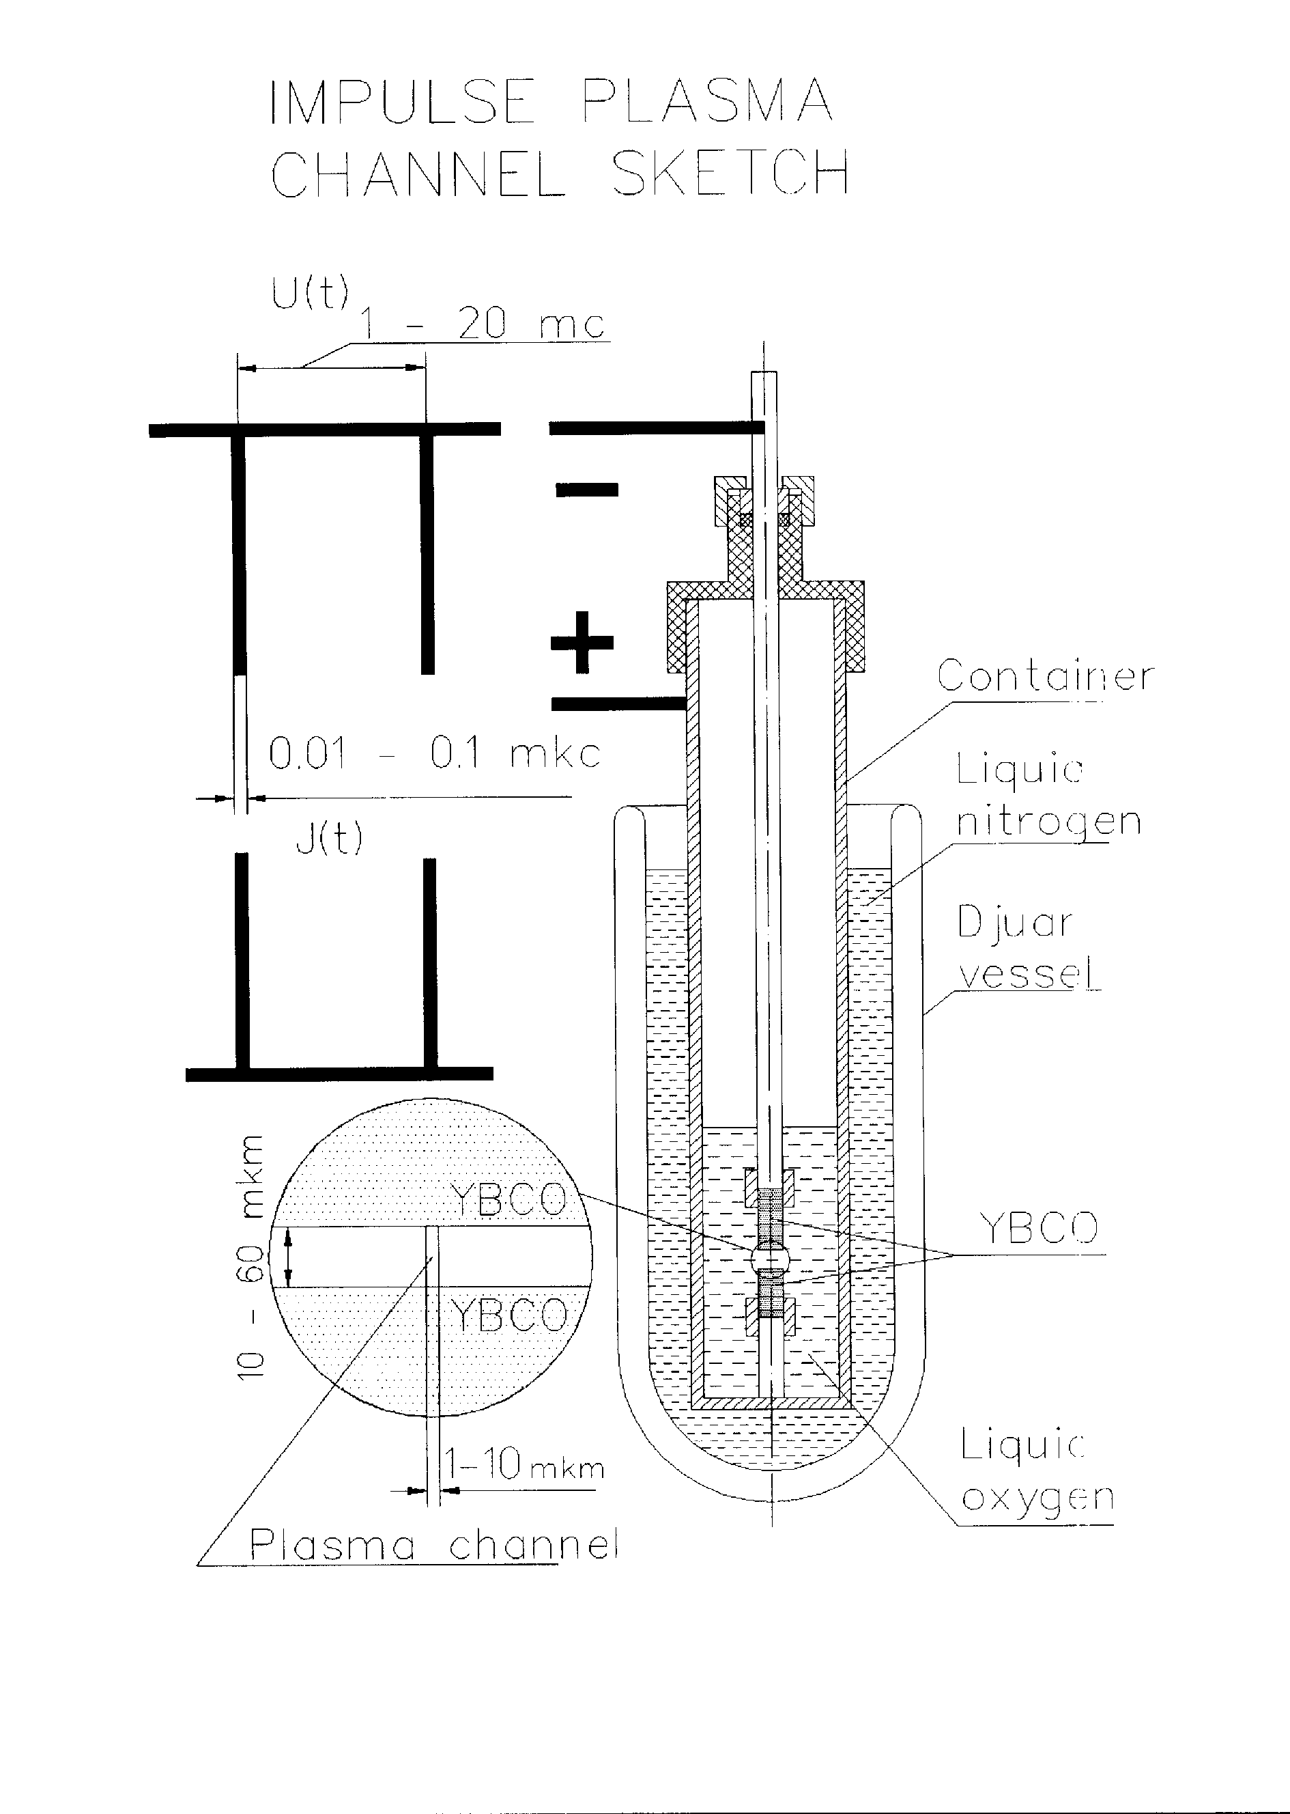
Fig. 1

Table 1. Particle size distribution in nano-scale powders.

Powder type | Specific surface, m²/g | Mean particle diameter, nm | Morphology and particle size, as revealed by TEM
Y123Ky-1-1 | 4.61 | ~200 | 1.Presence of small spherical particles 20-30 nm (Fig2,3)  2.Round-shaped particles of about 50 nm size (Fig.4)  3.Large plate-like crystals of about 1 mkm size with twin domains20-30 nm wide  (Fig.5,6)
Y123Ky-2-1 | 2.30-3.72 | ~250
Y123Ky-2-2 | 2.92 | ~300
Y123Ky-2-2` (850^{O}C) | 0.9 | ~1000
Nd-1 (x=0.1) | 2.9 | ~300
Nd-2 (x=0.2) | 2.8 | ~340
Nd-3 (x=0.4) | 4.1 | ~230
Ag (as grown) | 2.46 | ~230 | Round-shaped particles of 20-30 nm (Fig.7), associated in chains
Ag (100^{O}C,0.5h) | 2.18 | ~260
Ag (300^{O}C,0.5h) | 1.37 | ~400
ZrO2 | 14.37 | ~70

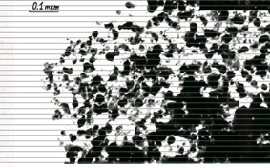  Fig.2 | 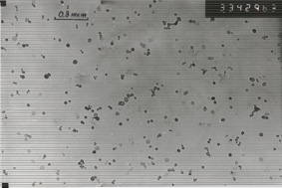  Fig.3
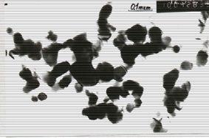  Fig.4 | 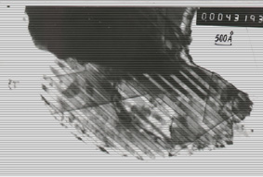  Fig.5
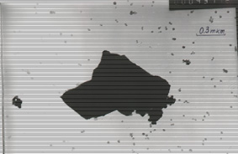  Fig.6 | 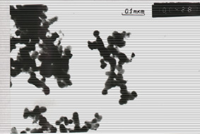  Fig.7

X-ray and electron diffraction
The unit cell parameters were calculated from 9 most intensive spectral lines. The following values were found: a=3.824±0.001A, b=3.890±0.001A , c=11.687±0.0025A (Table .2). It is worth noting that the powder prepared in Ar or O₂ atmospheres do not show differences in unit parameters, within the experimental accuracy. Two features of the nano-scale powders were observed from the X-ray data: presence of trace quantities of other phases (Y2BaCuO5, CuO, BaCuO2, BaCO3 ,Y2Ba4O7) and a halo in the range of 2θ = 27º-35º (Fig.8)

Table 2. X-ray data for YBCO nanopowders
Powder type | Identified phases | Unit cell parameters, A | Comments
Y123 Ky-2-1 (Fig.9) | YBa2Cu3O6.85  Y2BaCuO5- trace | a=3.824±0.001  b=3.890±0.001  c=11.687±0.0025 | powder prepared in Ar atmosphere
Y123 Ky-2-2 | YBa2Cu3O6.85  Y2BaCuO5- trace  BaCuO2 – trace  CuO - trace  BaCO3 – trace | a=3.823±0.001  b=3.888±0.001  c=11.686±0.0025 | powder prepared in O₂ atmosphere
Y123 (2+3)3 (Fig.10) | YBa2Cu3O6.85  Y2O3 - trace  2θ=27^{О}- 35^{О} – halo

To determine the phase composition of the halo, the electron diffraction patterns from the sample regions containing the finest powder fraction (<20 nm) were analysed. Presented in the Table 3 are results of the inter-plane distances calculations, and the phases identification, for one of the typical diffraction patterns. Diffraction pattern No. 43382

Table 3.
2R, mm | d_{exp ,} A | d, A  (123) | d, A (Y2BaCuO5) | D, A  (BaCuO2)
7.8 | 5.77 | 5.85(002) | 5.65(001) | 5.77(310)
8.7 | 5.17 |  | 5.13(011) | 5.27(222)
10 | 4.5 |  | 4.43(101) | 4.57(400)
11.2 | 4.01 | 3.9(003) | 4.06(030) | 4.08(420)
12 | 3.75 | 3.85(100) | 3.59(121) | 3.73(422)
13.8 | 3.26 | 3.22(102) | 3.3(031) | 3.23(440)
16 | 2.81 | 2.92(004) | 2.83(002) | 2.82(541)
17.5 | 2.57 | 2.65(111) | 2.57(022) | 2.56(551)
It is worth noting that lines in such diffraction patterns are often smeared. The analysis of the electron diffraction results shows that the finest particles (20 nm and below) consist mainly of BaCuO2 and Y2BaCuO5 phases. Only a small amount of YBa₂Cu₃O_{x} particles are present in this fraction. It was also possible to identify distinct YBa₂Cu₃O_{x} particles in the shape of irregular plates, 150 nm and over .
The finest fraction of YBCO powder was separated by centrifuging the powder immersed in alcohol. The finest fraction comprised 2%-5% of the total powder mass.
The X-ray analysis of this fraction has shown the following phases: BaCuO₃ - much, CuO - noticeable, Cu₂O - noticeable, Y₂O₃ - little, Y123 - little.
Thus the major phases responcible for the halo formation in the X-ray patterns, are BaCO3, CuO(Cu2O), Y2BaCuO5, BaCuO2. all these phases are products of partial decomposition of YBCO in the process of fine powder production. The element analysis has shown that the composition of the powder fully corresponds to the initial material composition.
Thus, the X-ray phase analysis and electron diffraction of YBCO fine powders have shown the following:
- The fraction of particles with 123 structure is not less than 95 % of the total powder mass. The size of YBCO particles is larger than 50 nm.
- The fraction of spurious phases is less than 5% mass. These include phases of BaCO3, CuO, Y2BaCuO5, BaCuO2. Spurious phases fall out as small particles (50 nm and less).
- The fraction of spurious phases depends on technological parameters of the powder preparation. Further work is needed to optimize these parameters and to eliminate spurious phases.

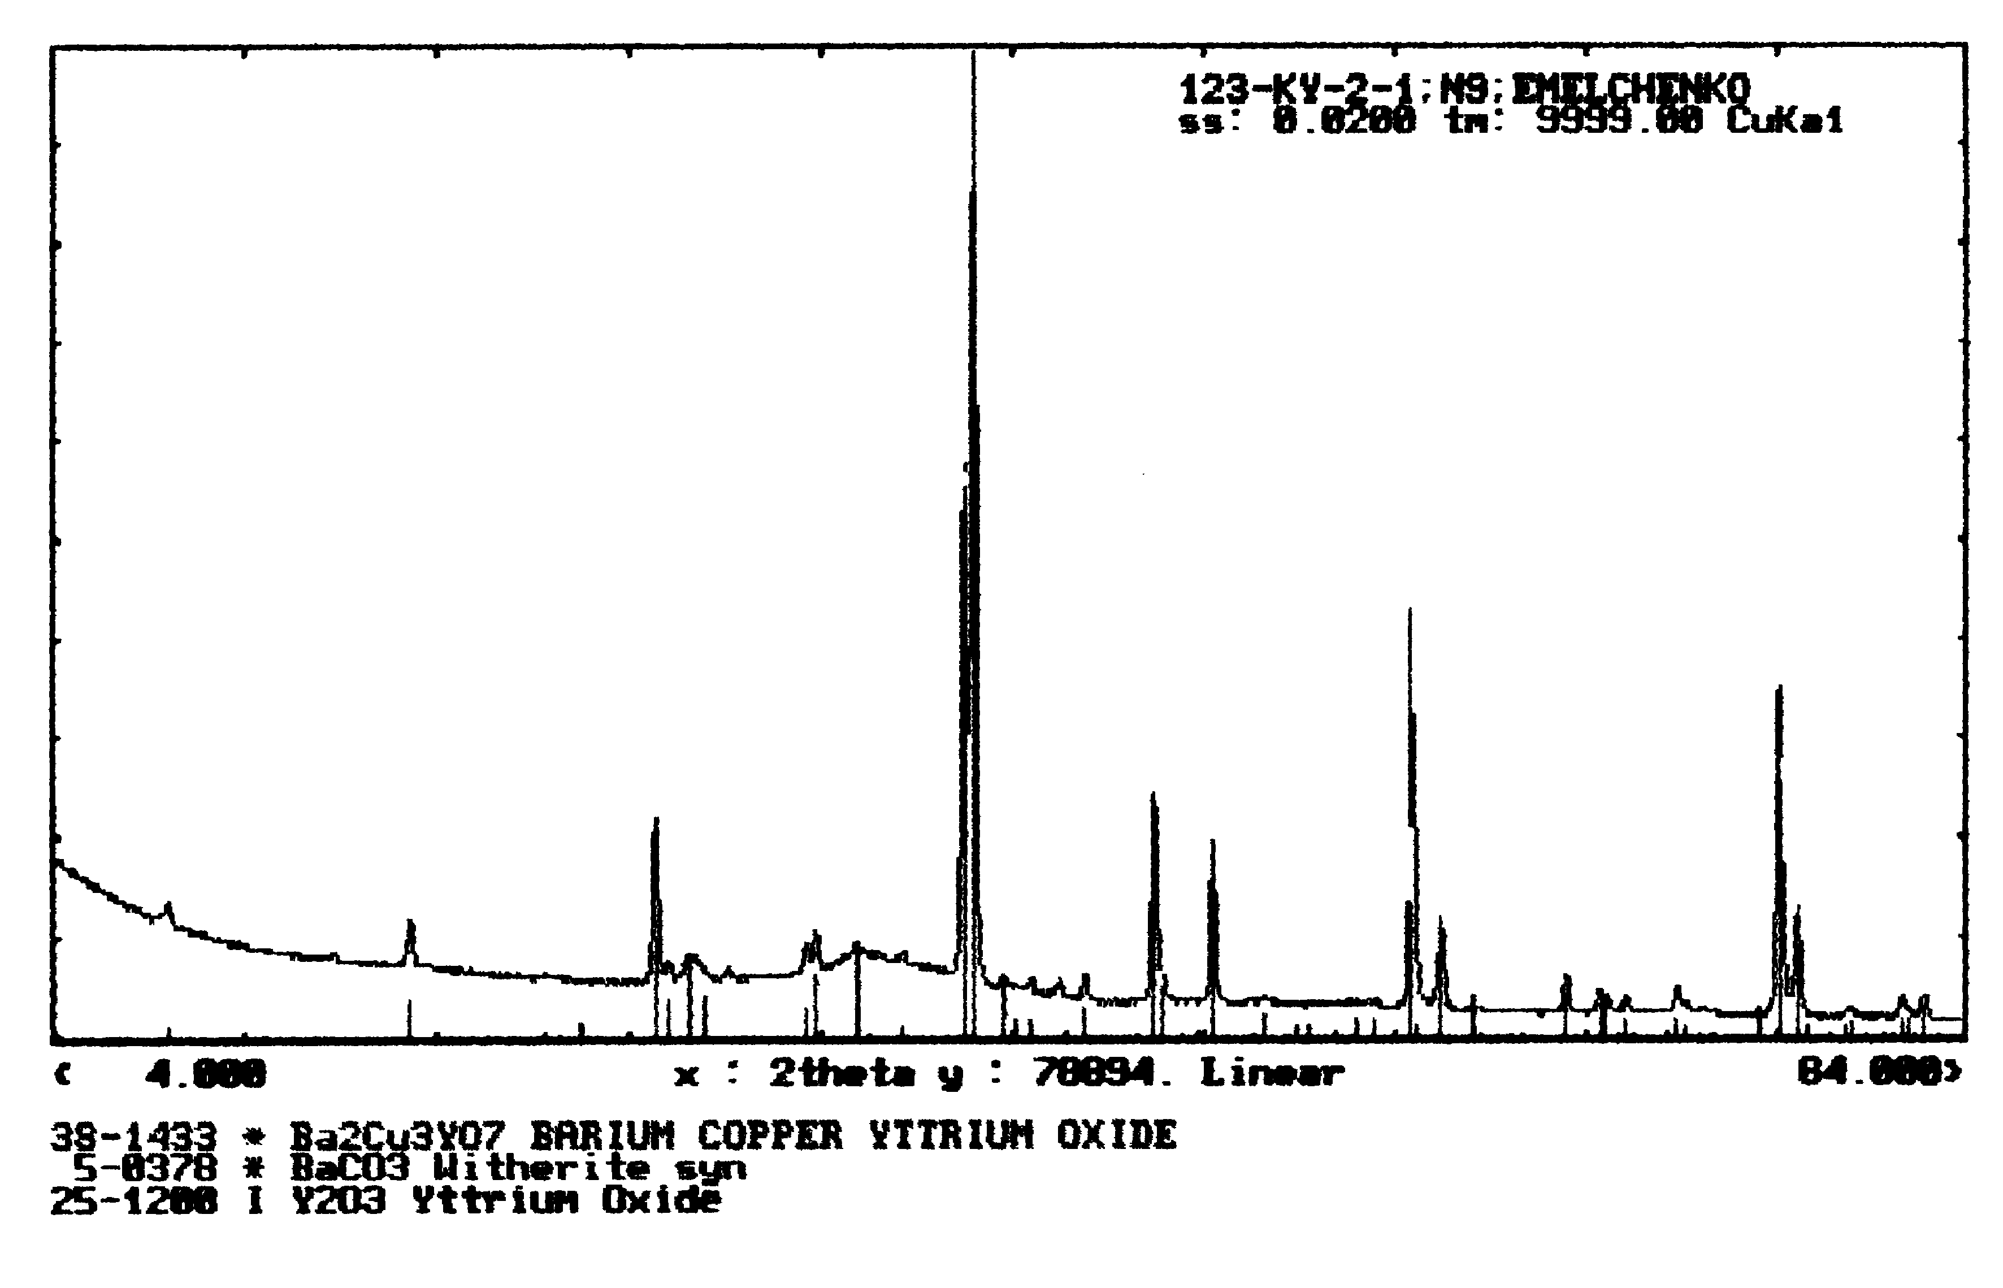
Fig.8

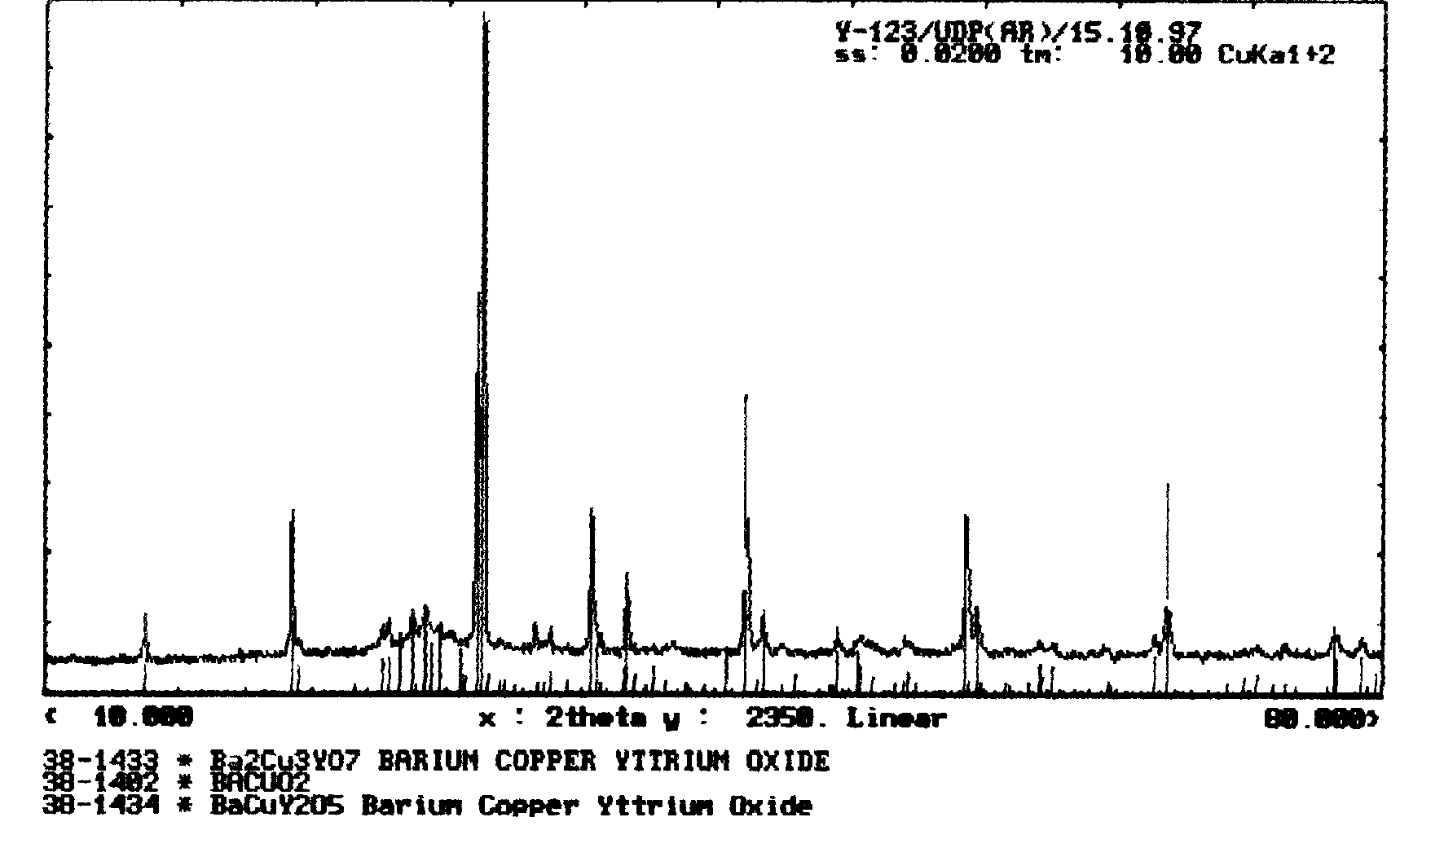
Fig.9

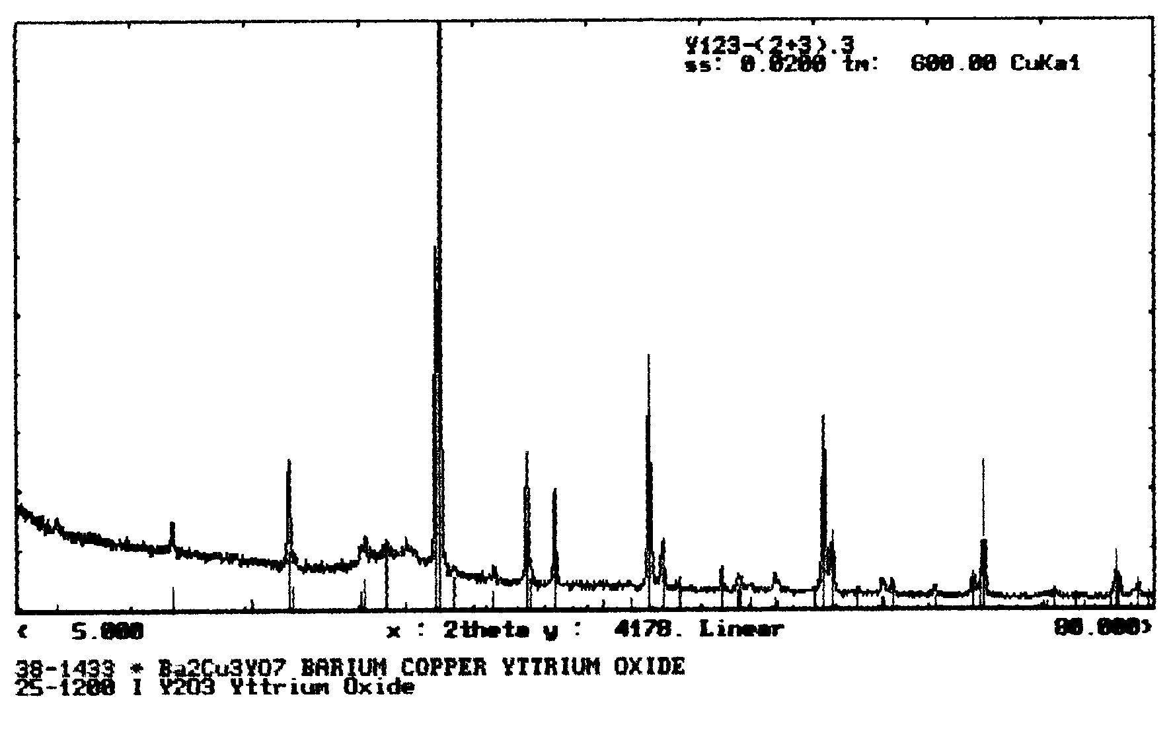
Fig.10

Differential Thermal Analysis
Presented in Fig. 11 is a typical DTA curve for a nano-scale powder (sample Y123 (2+3)). Besides the main peak around 1000 ºC corresponding to the melt reaction aYBa2Cu3Ox⇔bY2BaCuO5 + cL +dO2, an endothermal effect is observed on heating at 925-930 ºC, which corresponds to the eutectic reaction YBa2Cu3Ox + BaCuO2 + CuO⇔ L +O2.
Long-term annealing (66 hours) of the initial nano-scale particles at 485 ºC in oxygen atmosphere does not affect the two main features at 926 and 1000 ºC, but brings up a new noticeable feature at 984ºC (Fig. 12). It is possible that a reaction not involving the 123 phase takes place at this temperature: CuO +Y2BaCuO5 → Y2Cu2O5 +L + O2
Addition of the silver nano-scale powder (25% mass) to the YBCO nano-scale powder changes the DTA diagram substantially. As one can see in Fig. 13, there is a new peak at a lower temperature (around 880 ºC). A single-phase YBCO sample prepared by means of a standard solid-state synthesis technique, demonstrates only one large peak at around 1000 ºC (Fig. 14). A tiny fraction of spurious phases is revealed by DTA in this sample also, as manifested by a weak peak at around 950 ºC.
Thus, the differential thermal analysis confirms the presence of spurious phases in YBCO nano-scale powders.

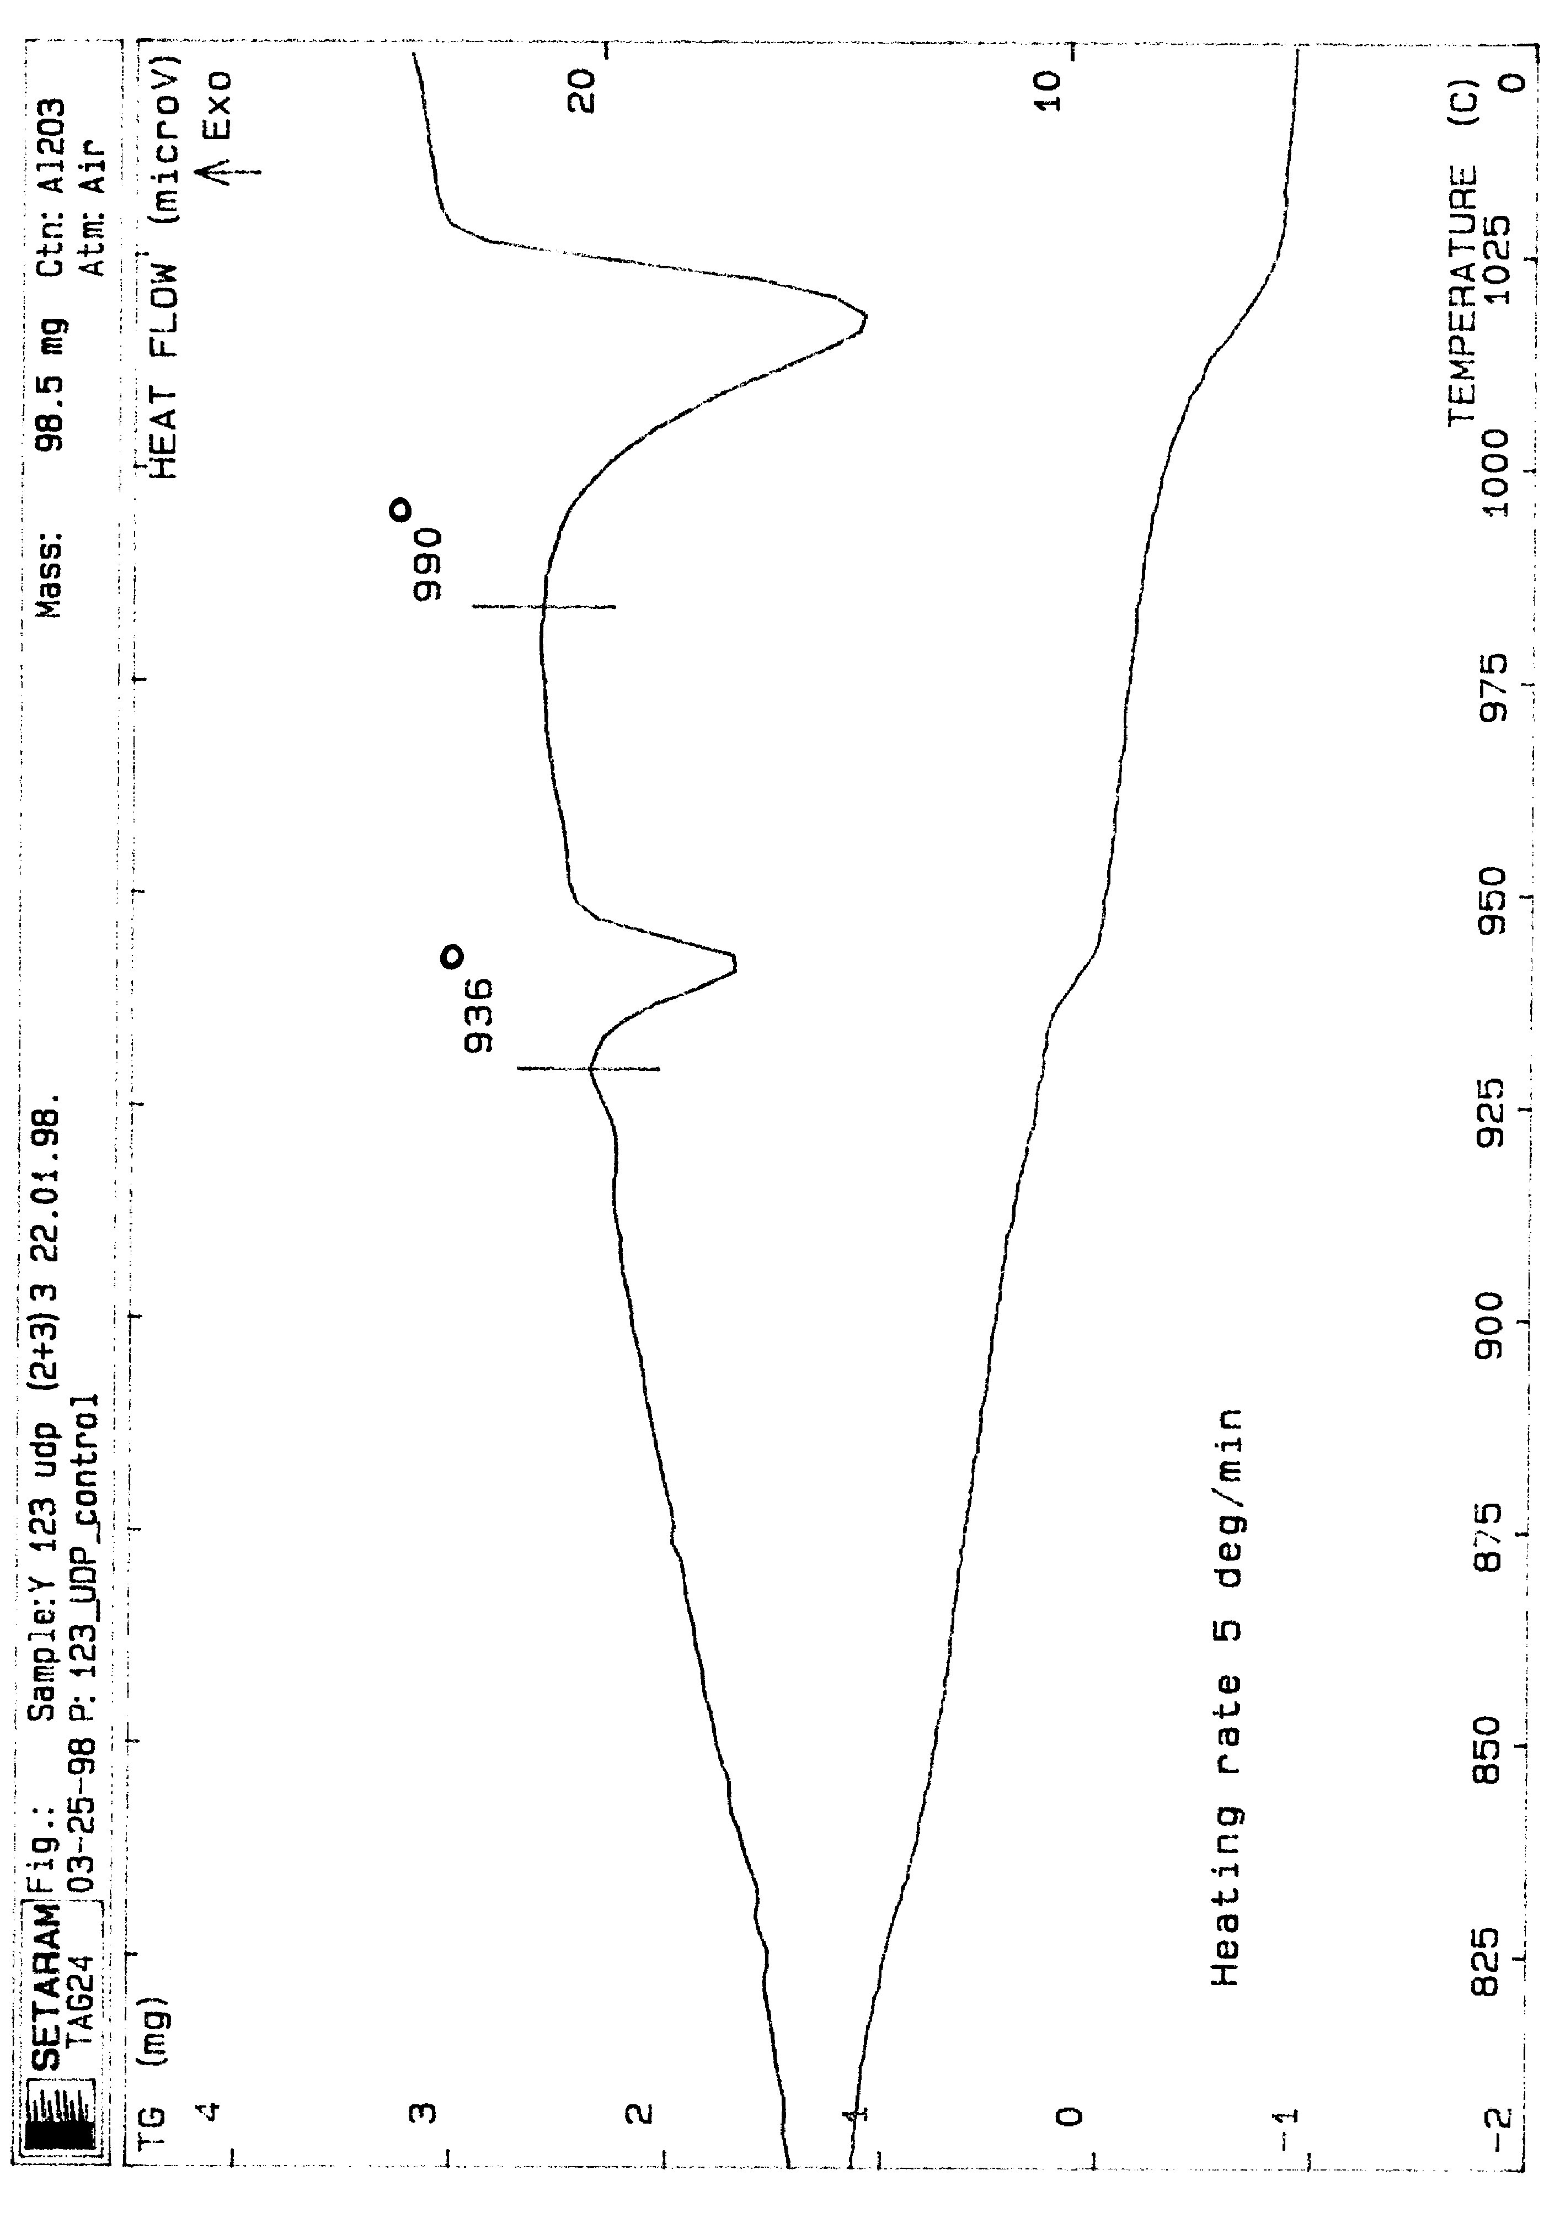
Fig.11
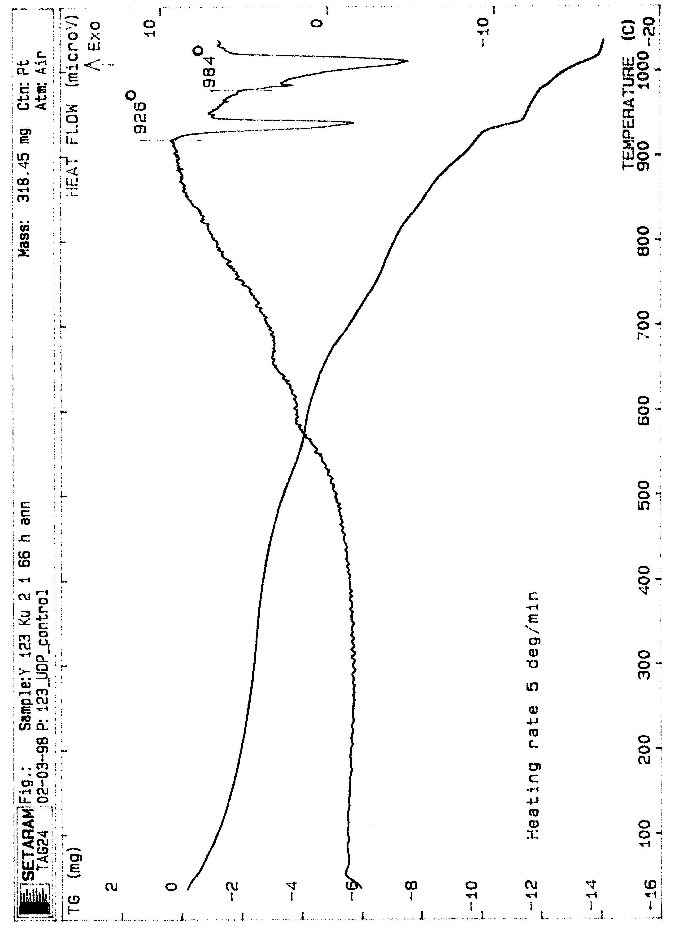
Fig.12
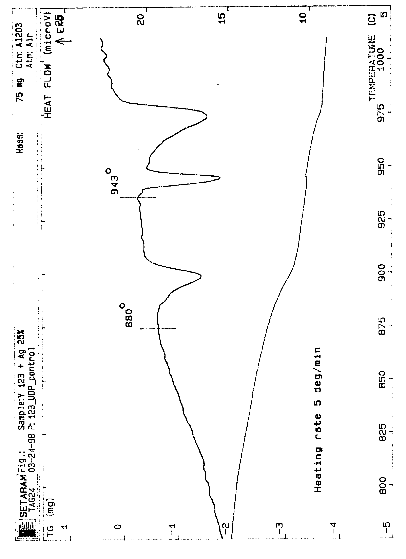
Fig.13

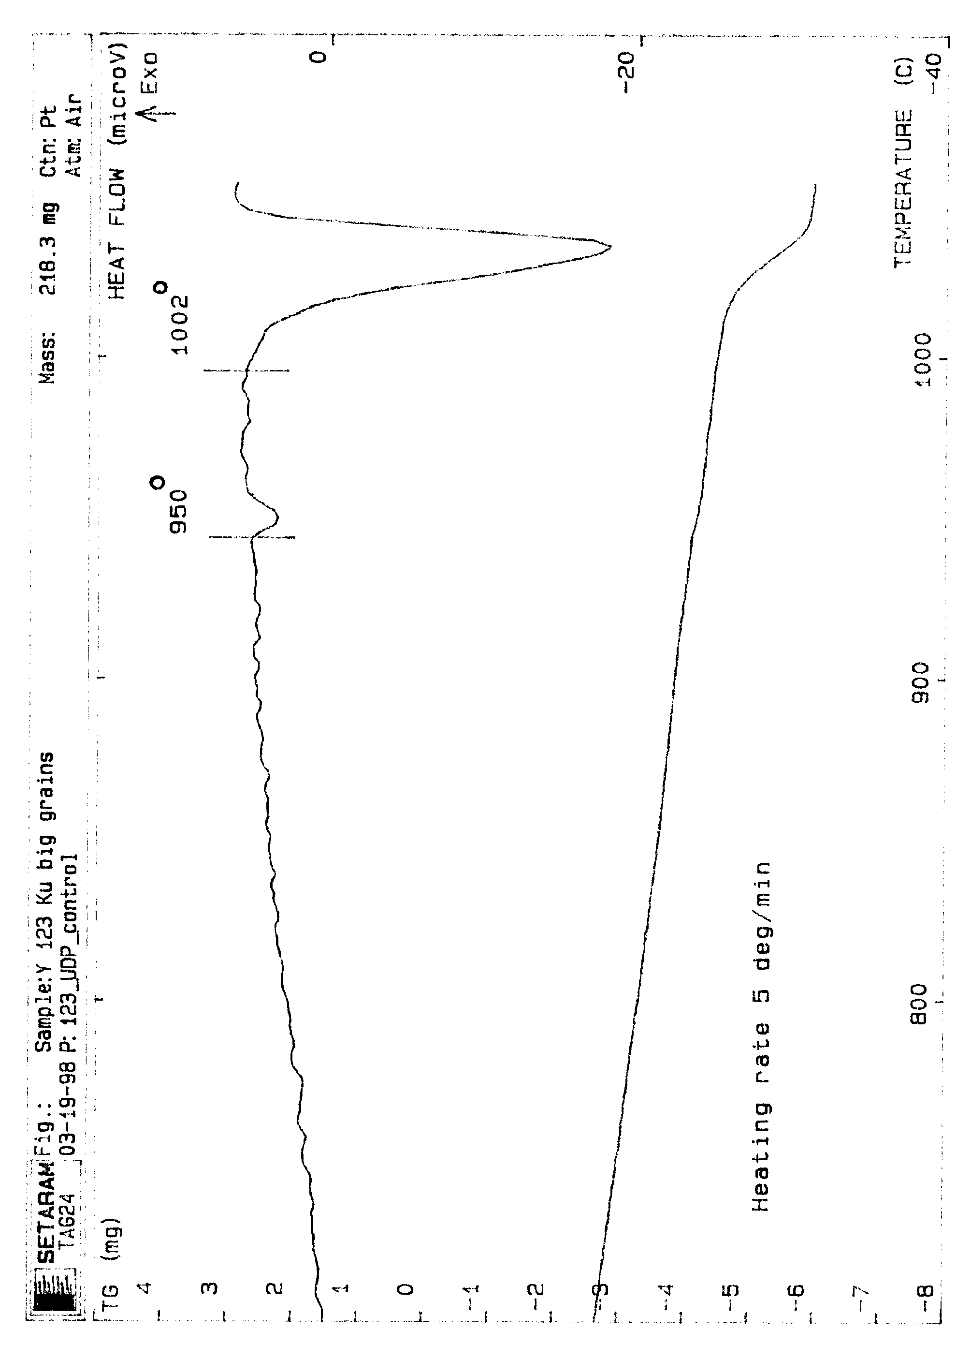
Fig.14

The critical temperature from magnetic susceptibility measurements.

The magnetic susceptibility χ was measured in the temperature range 4.2-100 K, in ac magnetic field at the frequency 10 kHz.
The dependence χ(T) varies with changing the powder preparation conditions: the initial material quality, energy and duration of the plasma channel pulses. Fig 15 shows typical dependences χ(T) for different conditions of powder preparation. For each initial ceramics there is an optimal range of the pulse energy and duration, yielding a single-step transition in χ(T) (curve 1). To the first approximation, the experimental dependence is well described by the theoretical formula for spherical particles of diameter d:
$$χ(T)=\frac{3}{8π}\left[1−3\frac{2λ(T)}{d}×\text{coth}\left(\frac{d}{2λ(T)}\right)\right]+3{\left(\frac{2λ(T)}{d}\right)}^{2}$$
$λ(T)=\frac{λ_{o}}{\sqrt{1−{\left(TT_{c}\right)}^{4}}}$.
The parameters used in fitting are T_{c} = 92 K, λ_{o} = 1500 A.

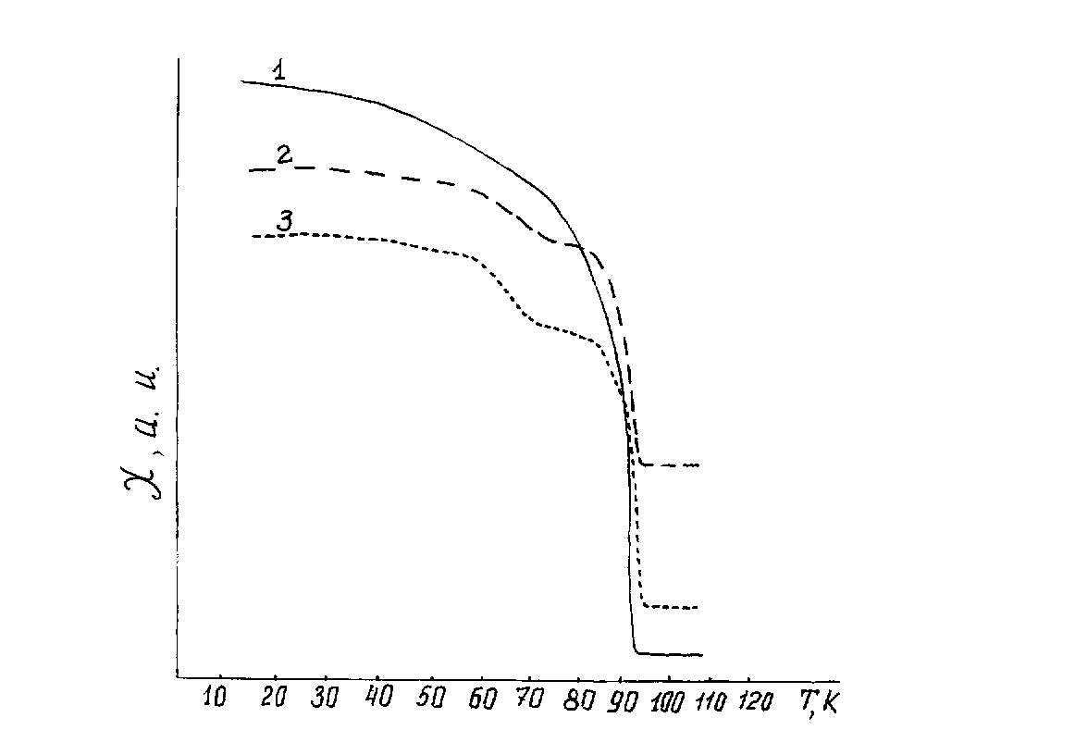
Fig.15

When the pulse energy and duration deviate from optimal values, χ(T) shows double-step transition, and the dependence can be described by sum of two contributions from materials with different T_{c} (Fig. 15, curve 2).
It should be noted that the powders that were characterized by single-step χ(T) curves just after the preparation, obtain a double-step transition as a result of oxygen annealing at 485 ºC for 66 hours (Fig. 15, curve 3). However, the X-ray phase analysis of the annealed powders did not reveal substantial quantities of 124 and 247 phases, which are superconducting with T_{c} different from T_{c} of 123 phase. It can be proposed that in the course of annealing, the oxygen content in 123 particles changes. The rate of oxygen variation is different for particles of different sizes. Since the critical temperature of 123 phase depends on the oxygen content, it can be assumed that the annealed powder comprises an ensemble of particles with different T_{c}, thus showing a double-step transition. It is possible that the powders that initially have a double-step transition olso contain particles with different oxygen content for different sizes.
So the analysis of χ(T) dependences has revealed that:
- the superconducting properties of the powders significantly depend on the preparation conditions , and
- granulometric and X-ray phase analysis are not sufficient for the powder attestation.

Oxygen index in YBa2Cu3Ox nano-scale powders.
The oxygen content in YBCO nano-scale powders was determined by photometric method, and from the c-axis unit cell parameter.
The photometric method has given the following values:
Y123 Ky-2-1 – x= 6.57
Y123 Ky-2-2 – x= 6.68
The oxygen index as estimated from the c-axis cell parameter was equal for both samples, x=6.85. Underestimated values of x obtained from photometric measurements, can be due to presence of spurious phases in the powders.

3. Investigations of ceramic sample (composites) prepared from nano-scale high-T_{c} powders.

Sample preparation technique.

The general scheme of composite preparation includes the following stages:
- mixing the powders by multiple sieving through a 40 mkm sieve (7 times)
- ultrasound treatment of powders immersed in alcohol;
- drying and pressing the tablets under the pressure of 200 MPa
- preliminary annealing in oxygen or in vacuum;
- hot pressing of the tablets under pressure of 100-400 MPa at temperature 700-950 ºC;
- saturation of the samples with oxygen.

Mechanical properties.
The mechanical tests were performed by means of Instron TT-BM-L testing machine. Presented in Table 4 are the results of flexural strength measurements, as measured by 3-point bending technique.

Table 4.

Sample number | Composition | σ, МРа
С-7 | Y123Ky1-1 | 108.5
C-10 | Y123Ky2-1 | 141
C-17-1 | Y123+ 25%Ag | 312
C-17-2 | Y123+25%Ag, anneal. | 336

Y123-Ag composites demonstrate high flexural strength as compared with undoped ceramics. The highest value of σ=336 MPa is more than 50% higher than the world best result for σ of 123 ceramics, obtained in the University of Birmingham.

Magnetic measurements.

Experimental technique.
Magnetic properties of superconducting powders and composites were studied by means of vibrating sample magnetometer. To measure the magnetization of fine powders, special cuvettes were used instead of a standard sample holder. The cuvette capacity was 1.4 10⁻² cm ³. The powders were poured into the cuvette and pressed with hand pressure.. This procedure is believed to result in some 30% filling factor. Samples of SC composites and textured materials were cut to have a typical volume of 2 10⁻³ cm³. Magnetization dependences on applied magnetic field were measured at 77 K.

Results.

a) powders and composites.
All the samples produced up to now showed quite similar character of magnetic hysteresis loops, illustrated in Fig.16. Hysteresis data are usually analyzed by decomposing a loop into reversible, M_{r}, and irreversible, M_{i}, components: M_{r} is the mean line of the hysteresis loop, and M_{i} is the loop width. The features of the samples studied are as follows:
1. The reversible and irreversible magnetization have similar magnitudes;
2. The irreversible component has a minimum at zero field, surrounded by two pronounced maxima;
3. When the field is decreasing, the magnetization runs with a nearly constant value.
The slope of the reversible magnetization at zero field is proportional to the volume of the superconducting (SC) material. This can be used for evaluation of the SC volume fraction in the samples. The SC fraction is a few percent for the samples studied, which suggests that the supercurrents do not flow on the length scale of the sample dimension, but are restricted to individual grains (or small clusters of grains). This suggestion agrees with the similarity in magnetic properties of powders and composites. So the shape of magnetization loops can be explained by influence of surface barriers for vortices at the surfaces of individual grains. Once it is accepted that the length scale of critical currents is the grain size, the values of intragrain critical current density can be estimated from the width of magnetization loop. Assuming that grains do not interact with each other, the following formula can be used for the grain irreversible magnetization:
$M_{g,i}=\frac{j_{c}R}{\text{15}}$. (1)
If the sample contains N grains of an equal volume v_{o}, then the sample magnetization (i.e., magnetic moment per unit volume of the sample) is
$M_{i}=\frac{{\text{Nv}}_{o}}{V}\frac{j_{c}R}{\text{15}}$, (2)
where V is the total volume of the sample. The first factor is the SC volume fraction, which is estimated from the reversible linear slope. The values of j_{c} obtained using (2) are reported in the table below. The calculated values of j_{c} are subject to uncertainty of the grain size determination. The hysteresis width was measured at field H=0.1 T. It was found that the field dependence of j_{c} follows the law j_{c}~(H)^{-1/2}. This allows to make an extrapolation and estimate j_{c} at 1 T field. The obtained values of intragrain j_{c} are on the level of best world results (Table 5,6 and diagrams ).
However, the problem remains of providing good contacts between individual grains. Neither magnetization nor transport measurements performed on the composite materials, have shown the presence of global current paths. It is believed that development of grain clusters will result in increase of the irreversible magnetization. It was found that there is a correlation between the value of "coercive force", H_{c} (see Fig. 16) and the parameters of thermal treatment. The increase of H_{c} is considered as an indication of cluster formation (in samples C35, C36-1, C38-11 and C37-3). Therefore the reported values of j_{c} for these samples can be overestimated, due to underestimation of the relevant length scale.

b) Melt-textured material.
Two small plates were cut from a melt-textured boule produced in Jena. The first plate came from the top part of the boule, another - from the bottom part. The linear magnetization at small field corresponds to full magnetic shielding in both samples. This shows that the samples are connected superconductors. However the values of j_{c} are different in the two samples: The values of j_{c} at H=0.3 T, T=77 K were 1.7 10³ A/cm² and 2 10² A/cm² for the "top" and "bottom" samples, respectively.

Conclusions.
From the experiments it can be concluded that the materials prepared using ultra fine powders have high values of intragrain currents. The major problem with the composite materials remains in presence of non-SC material on the grains' surface. Development of clusters brings up an increase of H_{c}, therefore this parameter will be checked for in further optimization of the material preparation procedure.

Conclusions.
1. Using the pulsed plasma channel method, the high-T_{c} nano-scale powders were produced, with the content of the primary phase not less than 95%. The further optimization of technological parameters is necessary to obtain single-phase YBCO product free of spurious phases.
2. Utilization of nano-scale powders resulted in bulk materials with densities up to 98% of the X-ray density.
3. Utilization of nano-scale particles in bulk materials production, allowed to decrease the consolidation temperature.
4. Bulk composites prepared from YBCO+Ag nanopowders have high mechanical characteristics.
5. Bulk composites of YBCO with addition of ZrO₂ nano-scale powder have high intra-grain critical currents.
6. To obtain high transport currents in bulk composites of YBCO nano-scale powders, it is necessary to produce single-phase powders free of spurious phases . It is a task of the next stage of study.

Fig.16 Fig.17
Fig. 18.

Figure captions:

Fig. 16. Magnetisation loop for the sample C-37-3 at 77K. The arrows show direction of the field sweep.
Fig. 17. Field dependence of the irreversible magnetisation.
Fig. 18. Field dependence of the intragrain critical current density. The dashed line is an extrapolation according to j_{c}~H^{-1/2}.
Table 5. Parameters derived from the magnetic measurements.

Sample | V_{sc}, cm³ |  | SC fraction | H_{c}, mT |  |  | J_{c}(0.1T), A/cm² |  |  | <d>, cm | J_{c}(1T),  estimated
Ky21 | 5.58E-04 |  | 4% | 3 |  |  | 2.61E+06 |  |  | 3.50E-05 | 8.16E+05
Ky22(kt22) | 8.37E-05 |  | 1% | 6 |  |  | 5.37E+06 |  |  | 3.00E-05 | 1.68E+06
Ky21-ot | 1.47E-04 |  | 1% | 4 |  |  | 6.14E+05 |  |  |  | 1.92E+05
C15 | 4.57E-05 |  | 5% | 5 |  |  | 8.54E+05 |  |  |  | 2.67E+05
C221 | 1.12E-05 |  | 1% | 2.5 |  |  | 9.67E+05 |  |  |  | 3.02E+05
C222 | non-superconducting
C23 | 5.23E-06 | 1% |  | 3 |  |  | 1.15E+06 |  |  |  | 3.58E+05
YBCO_large | 2.79E-05 | 3% |  | 2 |  |  | 5.91E+03 |  |  | 5.00E-03 | 1.85E+03
C35 | 4.19E-05 | 4% |  | 40 |  |  | 3.94E+06 |  |  | 5.00E-05 | 1.23E+06
C361 | 2.04E-05 | 2% |  | 20 |  |  | 4.41E+06 |  |  |  | 1.38E+06
C362 | 1.05E-05 | 1% |  | 10 |  |  | 1.15E+06 |  |  |  | 3.58E+05
X1 | 7.85E-05 | 8% |  | 14 |  |  | 2.14E+06 |  |  |  | 6.69E+05
X2 | 5.23E-05 | 5% |  | 7 |  |  | 1.09E+06 |  |  |  | 3.40E+05
T2 | 1.86E-05 | 2% |  | 7 |  |  | 8.06E+05 |  |  |  | 2.52E+05
C3721 | 4.19E-05 | 4% |  | 9 |  |  | 2.69E+06 |  |  | 8.00E-05 | 8.40E+05
C3722 | 6.28E-05 | 6% |  | 12 |  |  | 3.16E+06 |  |  | 8.00E-05 | 9.89E+05
C3723 | 3.45E-05 | 3% |  | 12 |  |  | 3.15E+06 |  |  | 8.00E-05 | 9.86E+05
C3811 | 3.45E-05 | 3% |  | 25 |  |  | 3.26E+06 |  |  | 8.00E-05 | 1.02E+06
C3812 | 3.91E-05 | 4% |  | 8 |  |  | 2.40E+06 |  |  | 8.00E-05 | 7.50E+05
C373 | 6.51E-05 | 7% |  | 35 |  |  | 6.33E+06 |  |  | 8.00E-05 | 1.98E+06
C3911 | 3.43E-05 | 3% |  | 4 |  |  | 1.20E+06 |  |  | 8.00E-05 | 3.76E+05
C3912 | 1.12E-05 | 1% |  | 9 |  |  | 2.35E+06 |  |  | 8.00E-05 | 7.35E+05
C40 | 5.58E-05 | 6% |  | 5 |  |  | 1.68E+06 |  |  | 8.00E-05 | 5.25E+05
C24 | non-superconducting

Table 6 The processing conditions and the intragrain Jc(magn.) of some samples at 77K and H=1 T.
Номер образца | Состав | Условия получения | D, mkm  The grain size | Jc (magn.)  (A/cm²)
Y123Ky-2-1 | YBa₂Cu₃O_{6.85} | IPC | ~ 0.35 | 8.16 10⁵
Y123Ky-2-1  (anneal.) | YBa₂Cu₃O_{6.85} | IPC | ~ 0.3 | 1.92 10⁵
Y123  Large grain ceramics | YBa₂Cu₃O₇ | Solid0 State synthesis | ~ 50 | 1.85 10³
C-15 | Y123Ky-2-1  (anneal.) | Hot Pressing(HP)  800^{O}C, 300 Mpa  Heat Treatm.(HT)  930^{O}C, O2,182 h.  485^{O}C, O2, 20 h. | ~ 3.0 | 2.67 10⁵
C-35 | Y123(2+3).3 | HP:730^{O}C,350 Mpa  HT:485^{O}C,120 h. | ~ 0.5 | 1.23 10⁶
C-37-2-1  -2  -3 | Y123 +  0.5%ZrO2 | HP:780^{O}C,85 Mpa  HT:400^{O}C,O2  - 15 h.  - 21 h.  - 95 h. | ~ 0.8  ~ 0.8  ~ 0.8 | 8.4 10⁵  9.89 10⁵  9.86 10⁵
C-38-1-1  -2 | Y123 +  0.5%ZrO2 | HP:780^{O}C,170 Mpa  HT:  -400^{O}C,O2,73 h.  -485^{O}C,O2,71 h. | ~ 0.8 | 1.02 10⁶  7.5 10⁵
VGO-10 | Y123Ky1-1 + Ky1-2 – 25%  IPHT-1 –75% | MMTG | ? | Jc(transp.) =1.7 10³

Diagrams of Jc, Hc and Sc fraction

