TDLS-2001
REPLY FORM
Last name
First name
Affiliation
Address
Phone
Fax
E-mail
I would like to be a participant in the conference accompanied by _______ person(s).
I plan to present a contribution:
Remarks:
Please return a reply form by September 2000
You may send a Reply Form by fax: +7(095)135-8281
or by e-mail -- just answer all of the above questions and send a message to: tdls@nsc.gpi.ru

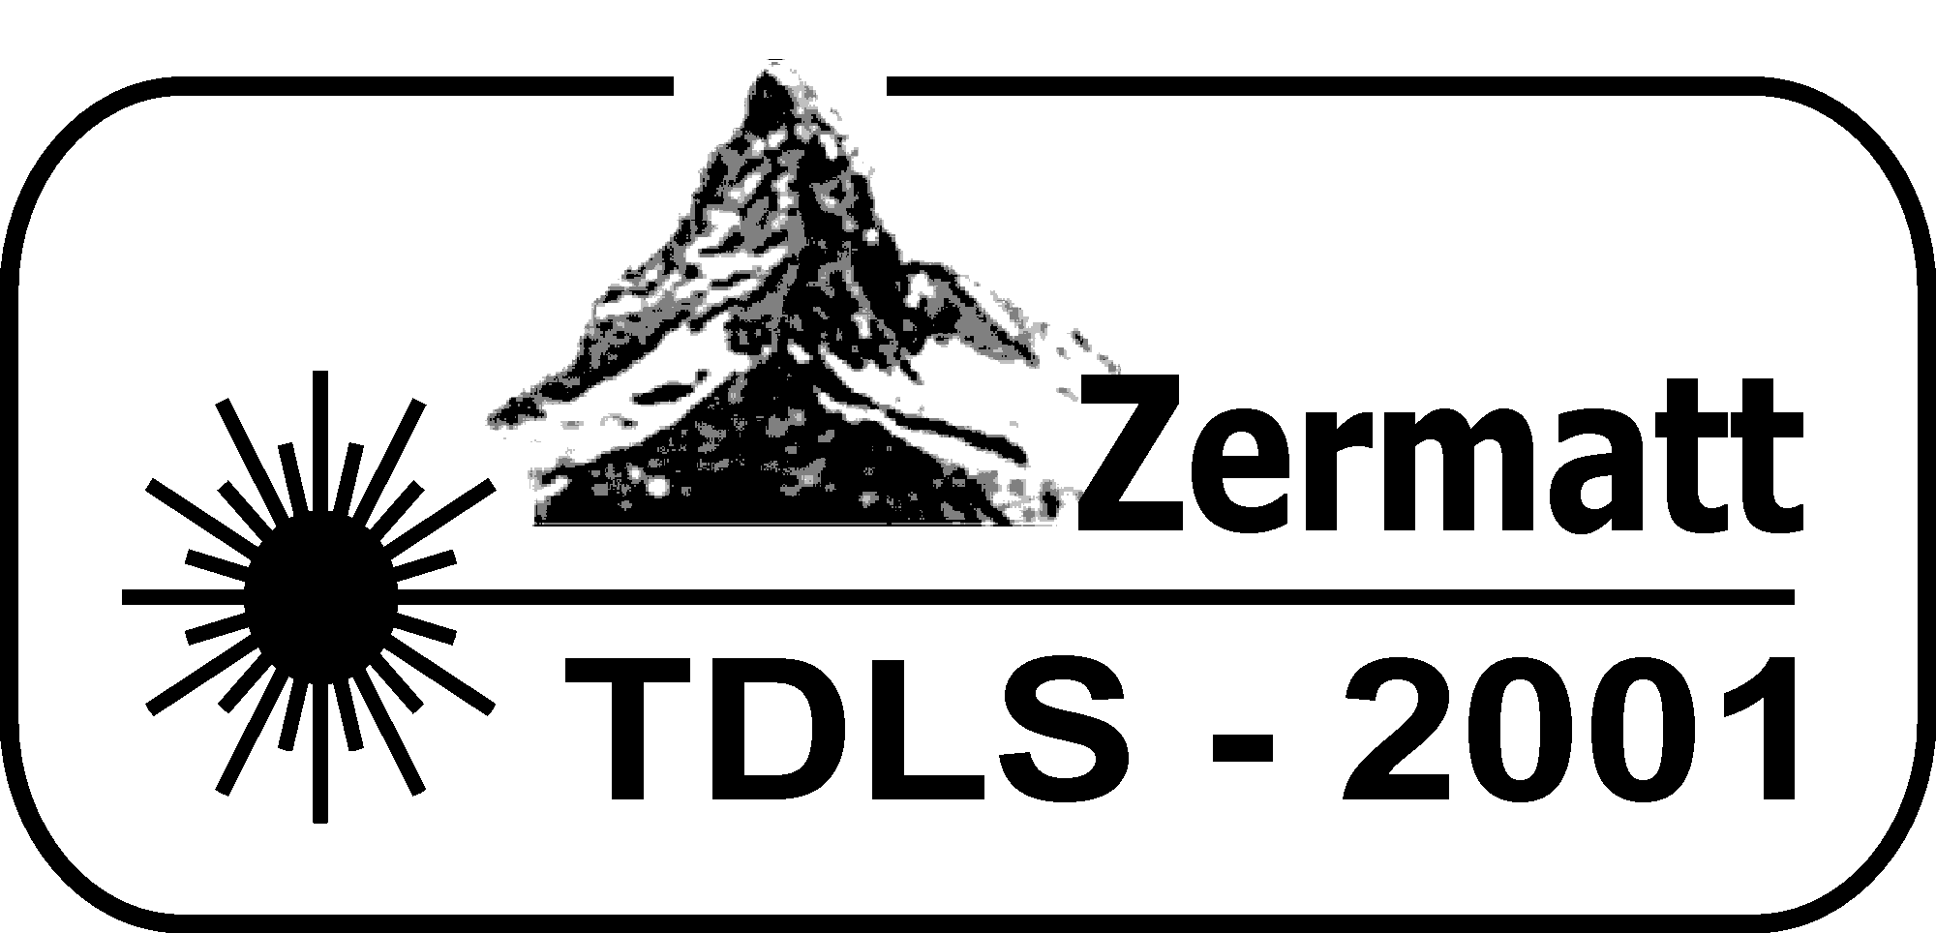

FIRST ANNOUNCEMENT

3rd International Conference on

Tunable Diode Laser Spectroscopy

July 8-12, 2001

Zermatt, Switzerland

This conference will be a meeting in the field of tunable diode laser spectroscopy

Conference Chairs:

Professor A. W. Mantz
Connecticut College
270 Mohegan Avenue New London,
Connecticut 06320-4196 USA
Phone: +1(860) 439 5030 Fax: +1(860) 439 5011
E-mail: awman@conncoll.edu

Professor A. I. Nadezhdinskii
General Physics Institute
Russian Academy of Sciences
38 Vavilov Street Moscow 117942, Russia
Phone: +7(095)135-8281 Fax: +7(095)135-8281
E-mail: nad@nsc.gpi.ru

Advisory Committee:

Ghislain Blanquet (Belgium)
Roberto Cingolani (Italy)
Alan Fried (USA)
Ryuji Koga (Japan)
Alain Valentin (France)
Peter Werle (Germany)
Maxim Spiridonov (Russia)
Gisbert Winnewisser (Germany)
Claude Thiebeaux (France)
Paul Davies (UK)
Hiroyuki Sasada (Japan)
Organized by
General Physics Institute, Russian Academy of Sciences, Moscow, Russia
Connecticut College, New London, Connecticut USA

Scientific Program
The scientific program covers a broad field of modern theoretical and experimental tunable diode laser spectroscopy. Two sessions will be held each day, morning and afternoon. The Conference schedule will include: invited lectures and poster sessions.
1. Semiconductor Lasers.
A_{III}B_{V}, A_{IV}B_{VI}, DFB lasers, quantum cascade lasers, photoelectric devices, laser noise, laser line width.
2. New Techniques and Technology.
Instrumentation and components, signal processing, fiber optics, calibration.
3. Fundamental Spectroscopy.
New spectral data, line profile studies, kinetics and photo chemistry.
4. Diagnostic and Process Monitoring.
Exhaust gas analysis, detection of explosives and drugs, isotope ratio measurements, plasma diagnostics.
5. Environmental Monitoring.
Atmospheric monitoring, instrument intercalibration, field experiments, laboratory studies.

Abstracts
Abstracts are accepted in electronic form and should be sent as e-mail attachments to: tdls@nsc.gpi.ru
WinWord format of abstracts is preferable.

Conference Proceedings
A special issue of Spectrochimica Acta will be prepared. Manuscripts should be submitted at the meeting or by mail to Arlan Mantz at Connecticut College, 270 Mohegan Avenue, New London, CT 06320-4196 prior to July 31, 2001.
Invited Speakers
Alfred Y. Cho, Lucent Technology, USA "Molecular Beam Epitaxy (MBE) Growth of Quantum Cascade Lasers"
Ronald K. Hanson, Stanford University, USA "Diode Lasers for Combustion Sensing and Control"
Jerome Faist, University of Neuchatel, Switzerland "Room Temperature Quantum Cascade Lasers for Gas and Liquid Spectroscopy"
Claude Alibert, Universite Montpellier, France "Gas Analysis Using Room Temperature Diode Lasers in the 2-2.5 Micron Range"
Maxim Spiridonov, General Physics Institute, Moscow, Russia "Precision Lineshape Measurements Using Near-IR Diode Lasers"
Trevor Sears, Brookhaven National Laboratory, USA "Diode Laser Spectroscopy of Molecular Free Radicals"
Yiriy Selivanov, Lebedev Physical Institute, Moscow, Russia "Recent Developments in Lead Salt-Based Nanostructures for Infrared Lasers"
Thomas Giesen Physikalisches Institut, University of Cologne, Germany "High Resolution IR-Spectroscopy of Small Carbon Clusters"
Andrei Berezin, General Physics Institute, Moscow, Russia "Trace Gas Detection with Near Infrared Diode Lasers".
Carlo Sirtori, Thompson-CSF, Orsay, France "Recent Development on GaAs Based Quantum Cascade Lasers"
Jan Peter Toennies, Max-Planck-Institut fur Stromungs-forschung, Goettingen, Germany "Superfluid He-Droplets: An Ultracold and Very Gentle Matrix for High Resolution Spectroscopy of Atom, Molecules and Clusters"
John P. Maier, Institut fur Physickalische Chemie, University of Basel, Switzerland. "Characterization of Ionic Complexes by Infrared diode Lasers"
Haruo Nagai, Anritsu Corporation, Atsugi, Kanagawa, Japan "Development on Gas Detection Systems using InGaAsP/InP Laser Diodes in 1.65-2um wavelength region"
Language
The Conference language is English.
Abstracts must be submitted in English.

Registration Fees
Registration fee for regular participants is 300 US$

Accommodation
Conference will be held in Hotel Zermatterhof.
Hotel rates are SFr 195 (about 120 US$) per person per day.
This includes a copious breakfast buffet, and a 4 course dinner. We will require non refundable first night Hotel deposit of 150 US$; the entire deposit will be applied to the first night room charge.
Participants should expect to arrive at the hotel Sunday July 8, 2001 and depart July 13, 2001
Detailed instructions for arrival will be supplied with Second Announcement.

Registration
If you plan to attend or to participate please complete the TDLS-2001 Reply Form in one of the following three ways:
- Fill in the reply form attached and send it to
Maxim Spiridonov, General Physics Institute
Vavilov street 38, Moscow 117942, Russia
- Answer the questions listed in the reply form and send by e-mail to tdls@nsc.gpi.ru
- Fill in the on-line registration form at:
http://www.dls.gpi.ru/TDLS/

Conference Web-Page
Please visit our Web Page to find recent information about the Conference
http://www.dls.gpi.ru/TDLS/

The Second Announcement will be sent out in November-December 2000

