TDLS-2001
REPLY FORM
Last name
First name
Affiliation
Address
Phone
Fax
E-mail
I would like to be a participant in the conference accompanied by _______ person(s).
I plan to present a contribution:
Remarks:
Please return a reply form by February 2001
You may send a Reply Form by fax: +7(095)135-8281
or by e-mail -- just answer all of the above questions and send a message to: tdls@nsc.gpi.ru

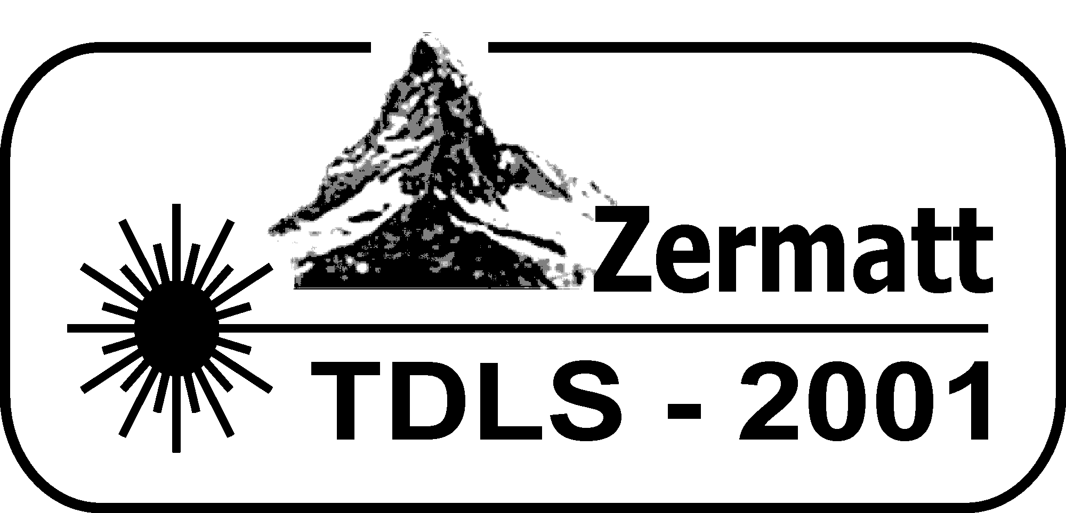

SECOND ANNOUNCEMENT

3rd International Conference on

Tunable Diode Laser Spectroscopy

July 8-12, 2001

Zermatt, Switzerland

This conference will be a meeting in the field of tunable diode laser spectroscopy

Conference Chairs:

Professor A. W. Mantz
Connecticut College
270 Mohegan Avenue, New London,
Connecticut 06320-4196 USA
Phone: +1(860) 439 5030
Fax: +1(860) 439 5011
E-mail: awman@conncoll.edu

Professor A. I. Nadezhdinskii
General Physics Institute
Russian Academy of Sciences
38 Vavilov Street, Moscow 117942, Russia
Phone: +7(095)135-8281
Fax: +7(095)135-8281
E-mail: nad@nsc.gpi.ru

Advisory Committee:

Ghislain Blanquet (Belgium)
Roberto Cingolani (Italy)
Alan Fried (USA)
Ryuji Koga (Japan)
Alain Valentin (France)
Peter Werle (Germany)
Maxim Spiridonov (Russia)
Gisbert Winnewisser (Germany)
Claude Thiebeaux (France)
Paul Davies (UK)
Hiroyuki Sasada (Japan)
Organized by
General Physics Institute, Russian Academy of Sciences, Moscow, Russia
Connecticut College, New London, Connecticut USA

Supported and Sponsored by:
Laser Components Instrument Group
Aquila Technologies Group
Ekips Technologies
Connecticut College

Scientific Program
The scientific program covers a broad field of modern theoretical and experimental tunable diode laser spectroscopy. The Conference schedule will include invited lectures and poster sessions.
1. Semiconductor Lasers.
A_{III}B_{V}, A_{IV}B_{VI}, DFB lasers, quantum cascade lasers, photoelectric devices, laser noise, laser line width.
2. New Techniques and Technology.
Instrumentation and components, signal processing, fiber optics, calibration.
3. Fundamental Spectroscopy.
New spectral data, line profile studies, kinetics and photo chemistry.
4. Diagnostic and Process Monitoring.
Exhaust gas analysis, detection of explosives and drugs, isotope ratio measurements, plasma diagnostics.
5. Environmental Monitoring.
Atmospheric monitoring, instrument intercalibration, field experiments, laboratory studies.

Abstracts
Abstracts are accepted in electronic form and should be sent as e-mail attachments to: tdls@nsc.gpi.ru
WinWord format of abstracts is preferable.
Abstracts will not be edited. Authors are fully responsible for both appearance and content of their submission.
The title should be centered and typed in upper case.
The name(s), affiliation and address of the author(s) should be centered and typed in upper and lower case letters.
Abstracts should be typed single spaced using Times 12 pts font. Margins should be at least the following: top - 3.5 cm; bottom - 2.5 cm; right - 2.5 cm; left - 2.5 cm (3 cm for Letter size paper). Maximum length is one page.
Deadline for abstracts submission is March 31, 2001

Conference Proceedings
A special issue of Spectrochimica Acta will be prepared. Manuscripts should be submitted at the meeting or by mail to Arlan Mantz at Connecticut College, 270 Mohegan Avenue, New London, CT 06320-4196 prior to July 31, 2001.

Registration Fees
before 31 Mar after 31 Mar
Regular Participants 300 US$ 350 US$
Students 150 US$ 200 US$
Accompanying persons 100 US$ 200 US$

Participants have two methods to pay fees; they are as follows:
By Check:
make check payable to:
Connecticut College, account B3239182-4339000
and send check to: Prof. A. W. Mantz
Department of Physics, Astronomy and Geophysics
Connecticut College 270 Mohegan Avenue
New London, CT 06320-4196
by Money Transfer (Bank to Bank)
Transfer to:
Fleet Bank, P. O. Box 40,000 Department 713 Hartford, Connecticut 06151 0313 USA

ABA Number 011900571
Account Number: 000 260 3780
Owner of account: Connecticut College

After a wire transfer is done send an e-mail personally to:
Arlan W. Mantz at awman@conncoll.edu explaining how much money was transferred and specific details regarding the different categories, including names of individuals, to which the funds which were transferred are to be credited.
Accommodations
Hotel Zermatterhof (preferred hotel)
195 SFr (about $120) per person per night.
This includes a copious breakfast buffet, and a 4
course dinner.
Hotel Alpina
82 SFr (about $50) per night, includes a breakfast
buffet.
Hotel Tannenhof
75 SFr (about $45) per night, includes a breakfast
buffet.

Conference will be held in Hotel Zermatterhof.
Arrangements for Hotel accommodations and for payment are the responsibility of each participant, student or accompanying person. All necessary information can be accessed through:
Conference WebPage at:
http://www.dls.gpi.ru/TDLS/
or Accommodations Page hosted in Cologne at:
http://www.ph1.uni-koeln.de/ZermattTDLS2001/index.html
or directly at Zermatt Accommodations Web Page:
http://www.zermatt.ch/accommodation/

Participants can register at the hotel of their choice
between December 15, 2000 and March 1, 2001
(some hotels may not be open before December 15).
Participants should expect to arrive at the hotel
on Sunday July 8, 2001 and depart on July 13, 2001.

Registration
If you plan to attend or to participate please
complete the TDLS-2001 Reply Form in one
of the following three ways:
- Fill in the reply form attached and send it to
Maxim Spiridonov, General Physics Institute
Vavilov Street 38, Moscow 117942, Russia
- Answer the questions listed in the reply form and
send by e-mail to tdls@nsc.gpi.ru
- Fill in the on-line registration form at:
http://www.dls.gpi.ru/TDLS/

The third announcement will be sent in
April 2001 by e-mail only, and only to
those participants who have registered

