TDLS-2003
REPLY FORM
Last name
First name
Affiliation
Address
Phone
Fax
E-mail
I would like to be a participant in the conference accompanied by _______ person(s).
I plan to present a contribution:
I plan to submit a manuscript  yes  no
Remarks:
Please return a reply form by December 2002
You may send a Reply Form by fax: 1-860-439-5011
or by e-mail -- just answer all of the above questions and send a message to: tdls@conncoll.edu or complete the form on the web at http://tdls.conncoll.edu/

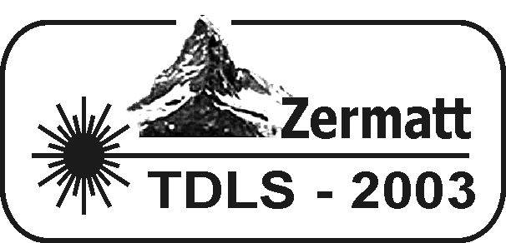

FIRST ANNOUNCEMENT

4th International Conference on

Tunable Diode Laser Spectroscopy

July 14-18, 2003

Zermatt, Switzerland

This conference will be a meeting in the
field of tunable diode laser spectroscopy

Conference Chairs:

Professor A. W. Mantz
Connecticut College
270 Mohegan Avenue New London,
Connecticut 06320-4196 USA
Phone: +1(860) 439 5030
Fax: +1(860) 439 5011
E-mail: awman@conncoll.edu

Professor A. I. Nadezhdinskii
General Physics Institute
Russian Academy of Sciences
38 Vavilov Street Moscow 117942, Russia
Phone: +7(095)135-8281
Fax: +7(095)135-8281
E-mail: nad@nsc.gpi.ru

Advisory Committee:
Claude Alibert (France)
Ghislain Blanquet (Belgium)
Paul Davies (UK)
Alan Fried (USA)
Armin Lambrecht (Germany)
Maxim Spiridonov (Russia)
Claude Thiebeaux (France)
Hiromichi Uehara (Japan)
Alain Valentin (France)
Peter Werle (Italy)
Gisbert Winnewisser (Germany)
Organized by
General Physics Institute, Russian Academy of Sciences, Moscow, Russia
Connecticut College, New London, Connecticut USA

Scientific Program
The scientific program covers a broad field of modern theoretical and experimental tunable diode laser spectroscopy. Two sessions will be held each day, morning and afternoon. The Conference schedule will include: invited lectures and poster sessions.
1. Semiconductor Lasers.
A_{III}B_{V}, A_{IV}B_{VI}, DFB lasers, quantum cascade lasers, photoelectric devices, laser noise, laser line width.
2. New Techniques and Technology.
Instrumentation and components, signal processing, fiber optics, calibration.
3. Fundamental Spectroscopy.
New spectral data, line profile studies, kinetics and photo chemistry.
4. Diagnostic and Process Monitoring.
Exhaust gas analysis, detection of explosives and drugs, isotope ratio measurements, plasma diagnostics.
5. Environmental Monitoring.
Atmospheric monitoring, instrument intercalibration, field experiments, laboratory studies.
6. Industrial Developments.
Analytical systems based on Tunable Diode Lasers.

Abstracts
Abstracts are accepted in electronic form and should be sent as e-mail attachments to: tdls@nsc.gpi.ru
Word format of abstracts is preferable. Abstract deadline March 15, 2003.

Conference Proceedings
A special issue of Spectrochimica Acta will be prepared. Manuscripts should be submitted at the meeting or by mail to Arlan Mantz at Connecticut College prior to June 30, 2003.
Confirmed Invited Speakers

Juergen Roepcke, Institute for Low Temperature Plasma Physics, Germany

Muriel Lepere, Free University Notre Dame de la Paix, Belgium

Dirk Richter, National Center for Atmospheric Research, USA,

Mark Zahniser, Aerodyne Research, USA,

Doug Baer, Los Gatos Research, USA,

Kay Niemax, Institute of Spectrochemistry and Applied Spectroscopy, University of Dortmund, Germany

Bertrand Parvitte, Universite de Reims France,

Georges Durry, CNRS, Institut Pierre Simon Laplace, France,

Daniel Hurtmans, Universite Libre de Bruxelles, Belgium

Frank K. Tittel, Rice University, USA,

Daniele Romanini, CNRS, Universite J. Fourier de Grenoble, France,

Daniel Hofstetter, University of Neuchatel, Institute of Physics, Switzerland,

Stephane Vannuffelen, Schlumberger, EPS-SRPC, France

Yuri Ponomarev, Instituite of Atmospheric Optics, Russia

Ohashi Nobukimi, Kanazawa University, Japan

Martin Fejer, Stanford University, USA
Language
The Conference language is English.
Abstracts must be submitted in English.

Registration Fees before March 31, 2003
- 350 US$ for regular participants
- 170 US$ for students
- 30 US$ for accompanying adults

Accommodations
Conference will be held in Hotel Zermatterhof.
Hotel rates are SFr 195 (about 120 US$) per person per day. This includes a copious breakfast buffet, and a 4 course dinner. Please consult the web page for more details. Participants should expect to arrive at the hotel Sunday July 13, 2003 and depart on July 17 late or on July 18, 2003
Detailed instructions for accommodations may be found on the web page.

Registration
If you plan to attend or to participate please complete the TDLS-2003 Reply Form in one of the following three ways:
- Fill in the reply form attached and send it to
Stacey Lion, TDLS Box 5243, Connecticut College, 270 Mohegan Ave., New London, CT 06320 USA
- Answer the questions listed in the reply form and send by e-mail to tdls@conncoll.edu
- Fill in the on-line registration form on the web page at: http://tdls.conncoll.edu/

Conference Web-Page
Please visit our Web Page to find recent information about the Conference
http://tdls.conncoll.edu/

The 2nd Announcement will be sent out by email only in January 2003.

